Spring Framework Training Sessions

# | Session | Topic | Date | Start Time | Duration
1 | Session 1 | Overview of Spring Framework | 04/28/15 | 11:00 AM IST | 1 Hr
2 | Session 1 | Spring Core Container | 04/28/15 | 11:00 AM IST | 1 Hr
3 | Session 2 | Spring MVC | 04/30/15 | 11:00 AM IST | 1 Hr
4 | Session 2 | Spring REST Support | 04/30/15 | 11:00 AM IST | 1 Hr
5 | Session 3 | Spring Data Access | 05/05/15 | 11:00 AM IST | 1 Hr
6 | Session 3 | Spring ORM Integration | 05/05/15 | 11:00 AM IST | 1 Hr
7 | Session 3 | Spring Transaction Management | 05/05/15 | 11:00 AM IST | 1 Hr
8 | Session 4 | Spring AOP Example | 05/07/15 | 11:00 AM IST | 1 Hr
9 | Session 4 | Spring Security | 05/07/15 | 11:00 AM IST | 1 Hr
10 | Session 4 | Spring Cache Abstraction | 05/07/15 | 11:00 AM IST | 1 Hr

# | Softwares Required
1 | JDK 1.6 or higher
2 | Eclipse
3 | Maven
4 | Tomcat 6 or higher
5 | MySQL or Oracle client

Table of Contents

Overview of Spring Framework 3
What is Spring Framework? 3
What is Software Development Framework? 3
Disadvantages of Spring Framework 4
How to overcome these difficulties? 4
Advantages of Spring Framework 5
Dependency Injection 6
Definition from the Web: 6
A very basic form of DI: 7
IOC (Inversion of Control) 8
Types of Dependency Injection supported by Spring 10
Setter-Based Dependency Injection 11
Constructor-Based Dependency Injection 15
Which type of DI to use? Constructor-based or setter-based DI? 17
Circular Dependency 17
Inner beans 18
Configuring Collections 19
Lazy Initialized Beans 20
Bean Autowiring 20
Bean Scopes 21
Bean Life-Cycle 22
Spring MVC 23

Overview of Spring Framework

What is Spring Framework?

Spring Framework is a Java based software development framework.

What is Software Development Framework?

- A Framework is a real or conceptual structure of a software.
- A Software Development Framework provides ready made structure of a software so that codes that are common to applications is not required to rewrite for a new application.
- Framework provides a running ‘Hello World’ kind of application that is easy to create.
- Developers need to write some minimal configuration codes and then can directly jump into implementing the business logics.
- Thus a framework reduces a lot of time and effort in software development work.

Disadvantages of Spring Framework

- It is too big and huge. So a considerable amount of learning curve is involved in it.
- A big documentation is there for this big framework that takes a lot of time to read.
- One thing can be achieved in different ways. So it involves a decision to make while selecting the best solution.
- A lot of configuration using XML or Annotation that makes it difficult to understand the natural flow of control.

How to overcome these difficulties?

- Think it in a different way. Instead of swallowing everything at a go, make small bites of it.
- Go through the project requirements first and then find which modules of Spring are needed to meet these requirements and then look into those modules one by one.

Case Study: I want to create a RESTful Webservice. Which modules of Spring I need to learn and in what sequence?

Learning Curve: Spring MVC. Learn how to create a Hello World Spring MVC application and then learn how to expose spring controllers as RESTful Webservices.

Advantages of Spring Framework

- No need to reinvent the wheel: Spring Framework provides almost all the solutions required to develop a modern Java/J2EE application. One framework all solutions. That’s why it is so popular.
- Integrates well with other frameworks: If you don’t like Spring’s way of implementing something and you want to use other frameworks for that part then Spring supports that.
- Open source: You have the source code so you can override or rewrite codes in your own way.
- Modularity: Spring is highly modular. So you can choose the modules required for your project and leave the modules that are not required.
- Loose Coupling: Spring promotes loose coupling principle of OOP.
- Light Weight: Spring is light weight and modularity helps to minimize the size of application libraries.
- Declarative Programming Model: The Declarative Programming Model of Spring reduces the number of lines of codes. It is observed in Transaction management, Security, etc.
- AOP: Spring provides a very good solution for AOP (Aspect Oriented Programing).
- IoC and Dependency Injection: It is one of the major benefits of Spring Framework.
- Testability: Spring projects are highly testable.

Dependency Injection

Dependency Injection is a design pattern that manages the creation of dependent objects.

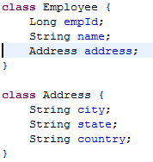 | 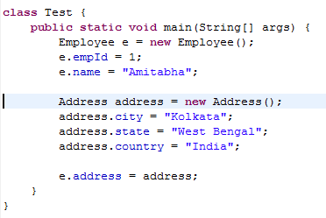
Code without Dependency Injection Framework

Employee HAS-A dependency, that is Address. To create an Employee object we also need to create an instance of Address object. Without Dependency Injection we need to write codes like “new Address()” to create the dependent objects.

Definition from the Web:
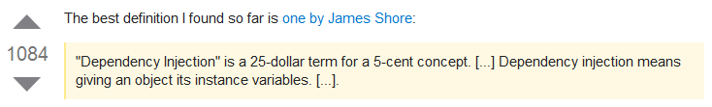

A very basic form of DI:

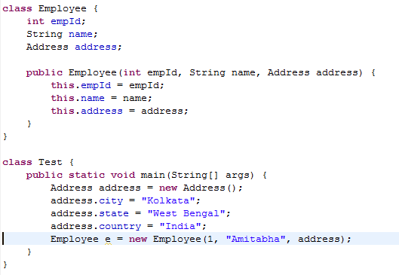

In this concept the dependant object is provided by a framework instead of creating objects with “new” operator in the programming code.

IOC (Inversion of Control)

Inversion of Control is a software development design pattern. It manages the life cycle of the resources that are used by the application.

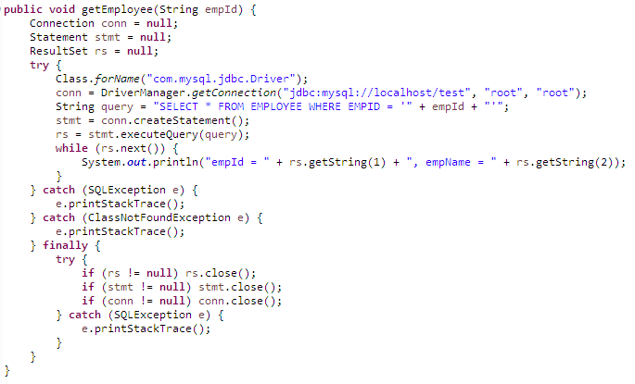
For example look at the following JDBC code:

Here the flow of control is as follows:

Step 1: Load and register the Driver
Step 2: Create Connection.
Step 3: Create Statement.
Step 4: Execute the query
Step 5: Loop through the ResultSet
Step 6: Close ResultSet.
Step 7: Close Statement.
Step 8: Close Connection.

With the help of IOC it will become like the following:

Step 1: NA
Step 2: NA.
Step 3: NA.
Step 4: Execute the query
Step 5: Loop through the ResultSet
Step 6: NA
Step 7: NA
Step 8: NA.

The framework will take of creating and managing the life cycle of Connection, Statement, ResultSet, etc and we can concentrate on executing the query and loop through the results.

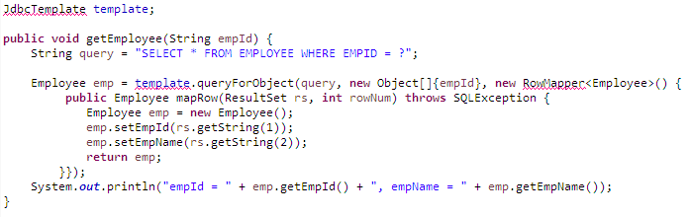
In Spring the code will look like:

The java components or resources that are created and managed by Spring Framework is known as Beans. Thus, IOC is the concept of managing the entire Bean life cycle.

Types of Dependency Injection supported by Spring

Spring supports two types of DI.

- Setter-based dependency injection
- Constructor-based dependency injection

Setter-Based Dependency Injection

Step 1: Let us create a maven quick-start project using the following command:

mvn archetype:generate -DgroupId=com.roy4j.spring4 -DartifactId=tutorial -DarchetypeArtifactId=maven-archetype-quickstart -DinteractiveMode=false

Step 2: Edit the “pom.xml” file and add Spring dependency:

<project xmlns="http://maven.apache.org/POM/4.0.0" xmlns:xsi="http://www.w3.org/2001/XMLSchema-instance" xsi:schemaLocation="http://maven.apache.org/POM/4.0.0 http://maven.apache.org/maven-v4_0_0.xsd">

<modelVersion>4.0.0</modelVersion>
<groupId>com.roy4j.spring4</groupId>
<artifactId>tutorial</artifactId>
<packaging>jar</packaging>
<version>1.0-SNAPSHOT</version>
<name>tutorial</name>
<url>http://maven.apache.org</url>

<properties>
<spring.framework.version>4.1.6.RELEASE</spring.framework.version>
</properties>
<dependencies>
<dependency>
<groupId>org.springframework</groupId>
<artifactId>spring-context</artifactId>
<version>${spring.framework.version}</version>
</dependency>
<dependency>
<groupId>junit</groupId>
<artifactId>junit</artifactId>
<version>3.8.1</version>
<scope>test</scope>
</dependency>
</dependencies>
</project>

Step 3: Let us create Employee.java and Address.java

Employee.java
package com.roy4j.spring4;

public class Employee {
private String empId;
private String empName;
private Address address;

public Employee() {
}

public Employee(String empId, String empName, Address address) {
this.empId = empId;
this.empName = empName;
this.address = address;
}

public String getEmpId() {
return empId;
}

public void setEmpId(String empId) {
this.empId = empId;
}

public String getEmpName() {
return empName;
}

public void setEmpName(String empName) {
this.empName = empName;
}

public Address getAddress() {
return address;
}

public void setAddress(Address address) {
this.address = address;
}

public String toString() {
return "Employee [empId=" + empId + ", empName=" + empName + ", address=" + address + "]";
}
}

Address.java
package com.roy4j.spring4;

public class Address {
private String city;
private String state;
private String country;

public String getCity() {
return city;
}

public void setCity(String city) {
this.city = city;
}

public String getState() {
return state;
}

public void setState(String state) {
this.state = state;
}

public String getCountry() {
return country;
}

public void setCountry(String country) {
this.country = country;
}

public String toString() {
return "Address [city=" + city + ", state=" + state + ", country=" + country + "]";
}
}

Step 4: Let us create “beans.xml” file in “src/main/resources” directory and configure the definitions for Employee and Address.

src/main/resources/ beans.xml
<?xml version="1.0" encoding="UTF-8"?>
<beans xmlns="http://www.springframework.org/schema/beans"
xmlns:xsi="http://www.w3.org/2001/XMLSchema-instance"
xsi:schemaLocation="http://www.springframework.org/schema/beans
http://www.springframework.org/schema/beans/spring-beans.xsd">

<bean id="employee" class="com.roy4j.spring4.Employee">
<property name="empId" value="796763" />
<property name="empName" value="Amitabha Roy" />
<property name="address" ref="address" />
</bean>

<bean id="address" class="com.roy4j.spring4.Address">
<property name="city" value="Calcutta" />
</bean>
</beans>

Step 5: Let us create “Main.java” where we will use setter-based dependency injection:

Main.java
package com.roy4j.spring4;

import org.springframework.context.ApplicationContext;
import org.springframework.context.support.ClassPathXmlApplicationContext;

public class Main {

public static void main(String[] args) {
ApplicationContext context = new ClassPathXmlApplicationContext("beans.xml");
Employee emp = (Employee) context.getBean("employee");
System.out.println(emp);
}
}

Step 6: The out put of this code is:

Apr 27, 2015 4:09:06 PM org.springframework.context.support.ClassPathXmlApplicationContext prepareRefresh
INFO: Refreshing org.springframework.context.support.ClassPathXmlApplicationContext@ab50cd: startup date [Mon Apr 27 16:09:06 IST 2015]; root of context hierarchy
Apr 27, 2015 4:09:06 PM org.springframework.beans.factory.xml.XmlBeanDefinitionReader loadBeanDefinitions
INFO: Loading XML bean definitions from class path resource [beans.xml]
Employee [empId=796763, empName=Amitabha Roy, address=Address [city=Calcutta, state=null, country=null]]

Constructor-Based Dependency Injection

Step 1: Let us add two new bean definitions in the beans.xml file:

<bean id="employee1" class="com.roy4j.spring4.Employee">
<constructor-arg name="empId" value="233208" />
<constructor-arg name="empName" value="Abir Dutta" />
<constructor-arg name="address" ref="address1" />
</bean>

<bean id="address1" class="com.roy4j.spring4.Address">
<property name="city" value="Mumbai" />
</bean>

Step 2: Let us modify the “Main.java” and get the bean “employee1”:

Main.java
package com.roy4j.spring4;

import org.springframework.context.ApplicationContext;
import org.springframework.context.support.ClassPathXmlApplicationContext;

public class Main {

public static void main(String[] args) {
ApplicationContext context = new ClassPathXmlApplicationContext("beans.xml");
Employee emp = (Employee) context.getBean("employee1");
System.out.println(emp);
}
}

Step 3: Now the output is:
Apr 27, 2015 4:04:36 PM org.springframework.context.support.ClassPathXmlApplicationContext prepareRefresh
INFO: Refreshing org.springframework.context.support.ClassPathXmlApplicationContext@ab50cd: startup date [Mon Apr 27 16:04:36 IST 2015]; root of context hierarchy
Apr 27, 2015 4:04:36 PM org.springframework.beans.factory.xml.XmlBeanDefinitionReader loadBeanDefinitions
INFO: Loading XML bean definitions from class path resource [beans.xml]
Employee [empId=233208, empName=Abir Dutta, address=Address [city=Mumbai, state=null, country=null]]

Which type of DI to use? Constructor-based or setter-based DI?

You are free to use any of them as per your requirement. You can even mix these two types. However, it is a recommended practice that for mandatory dependencies one should use constructor-based DI and for optional dependencies one should use setter-based DI.

Circular Dependency

Suppose, object A depends on B and object B depends on A. At runtime Spring IOC container will detect this circular dependency.

If you use constructor-based DI then BeanCurrentlyInCreationException will be trrown. To avoid this scenario the best solution is to modify the source code and change the architecture and break this circular dependency.

If it is not possible to break the circular dependency then use setter-based DI which will not throw any exception but the dependent objects might not be instantiated as expected.

Inner beans

Yes, Spring supports inner beans or nested bean configuration. We can configure Inner beans as follows:

<bean id="employee2" class="com.roy4j.spring4.Employee">
<property name="empId" value="796763" />
<property name="empName" value="Amitabha Roy" />
<property name="address">
<bean class="com.roy4j.spring4.Address">
<property name="city" value="Mumbai" />
</bean>
</property>
</bean>

Configuring Collections

<bean id="moreComplexObject" class="example.ComplexObject">

<!-- results in a setSomeList(java.util.List) call -->
<property name="someList">
<list>
<value>a list element</value>
<value>a list element</value>
</list>
</property>

<!-- results in a setSomeMap(java.util.Map) call -->
<property name="someMap">
<map>
<entry key="an entry" value="just some string" />
<entry key="a ref" value-ref="myDataSource" />
</map>
</property>

<!-- results in a setSomeSet(java.util.Set) call -->
<property name="someSet">
<set>
<value>just some string</value>
<value>just some string</value>
</set>
</property>

<!-- results in a setAdminEmails(java.util.Properties) call -->
<property name="adminEmails">
<props>
<prop key="administrator">administrator@example.org</prop>
<prop key="support">support@example.org</prop>
<prop key="development">development@example.org</prop>
</props>
</property>
</bean>

Lazy Initialized Beans

<bean id="employee" class="com.roy4j.spring4.Employee">
<property name="empId" value="796763" />
<property name="empName" value="Amitabha Roy" />
<property name="address" ref="address" />
</bean>

<bean id="address" class="com.roy4j.spring4.Address" lazy-init="true">
<property name="city" value="Calcutta" />
</bean>

Bean Autowiring

One bean is referring to another bean is know as bean wiring. Bean wiring is done by the “ref” attribute. We have already seen it:

<property name="address" ref="address" />

This is manual process. There is an annotation @Autowored which can do this bean wiring automatically.

Step 1: Remove the above manual wiring code from “beans.xml” file.

Step 2: Add the following line in “beans.xml”:

<context:annotation-config />

It will enable annotation support.

Step 3: Annotate the Address field in “Employee.java” with @Autowored annotation.

@Autowired
private Address address;

Bean Scopes
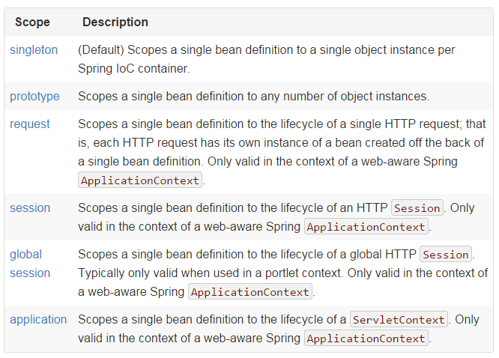

Bean Life-Cycle
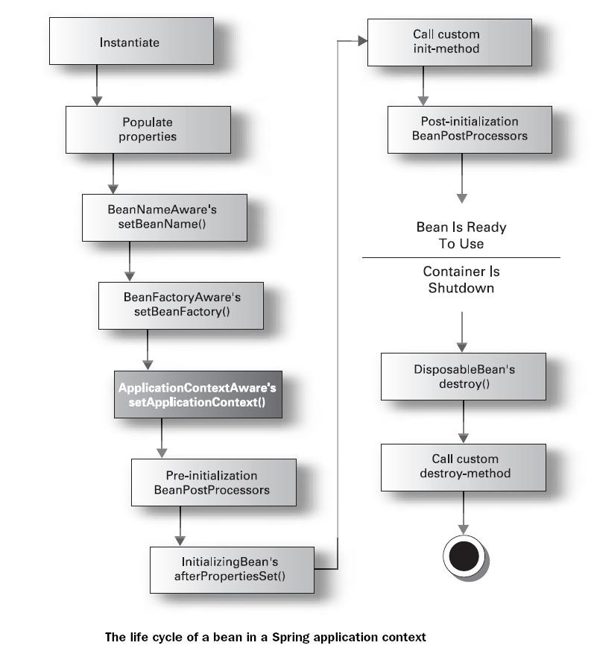

Spring MVC

What is MVC?

MVC is an architectural design pattern. In MVC the application code is divided into three layers: Model, View and Controller.

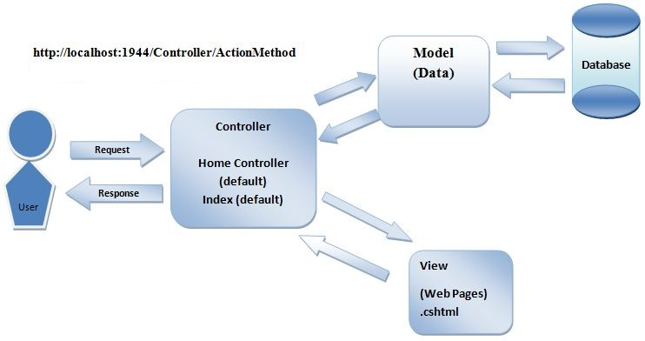

The DispatcherServlet

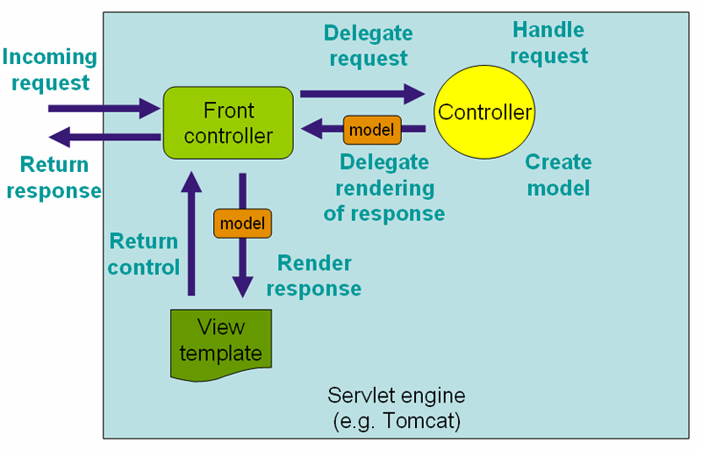
The request processing workflow in Spring Web MVC (high level)

Modify web.xml to add DispatcherServlet

<servlet>
<servlet-name>dispatcher</servlet-name>
<servlet-class>org.springframework.web.servlet.DispatcherServlet</servlet-class>
<load-on-startup>1</load-on-startup>
</servlet>

<servlet-mapping>
<servlet-name>dispatcher</servlet-name>
<url-pattern>/</url-pattern>
</servlet-mapping>

Spring Configuration File

Spring will search a file named “dispatcher-servlet.xml” in the location od “web.xml” file for Spring bean configurations. If we want to change this default configuration then we need to add

<listener>
<listener-class>org.springframework.web.context.ContextLoaderListener</listener-class>
</listener>

<context-param>
<param-name>contextConfigLocation</param-name>
<param-value>/WEB-INF/beans.xml</param-value>
</context-param>

dispatcher-servlet.xml

<beans xmlns="http://www.springframework.org/schema/beans"
xmlns:context="http://www.springframework.org/schema/context"
xmlns:xsi="http://www.w3.org/2001/XMLSchema-instance"
xmlns:mvc="http://www.springframework.org/schema/mvc"
xsi:schemaLocation="
http://www.springframework.org/schema/beans
http://www.springframework.org/schema/beans/spring-beans.xsd
http://www.springframework.org/schema/mvc
http://www.springframework.org/schema/mvc/spring-mvc.xsd
http://www.springframework.org/schema/context
http://www.springframework.org/schema/context/spring-context.xsd ">

<mvc:annotation-driven />
<context:component-scan base-package="com" />

</beans>

@Controller

@RequestMapping

What is AOP (Aspect Oriented Programming)?

